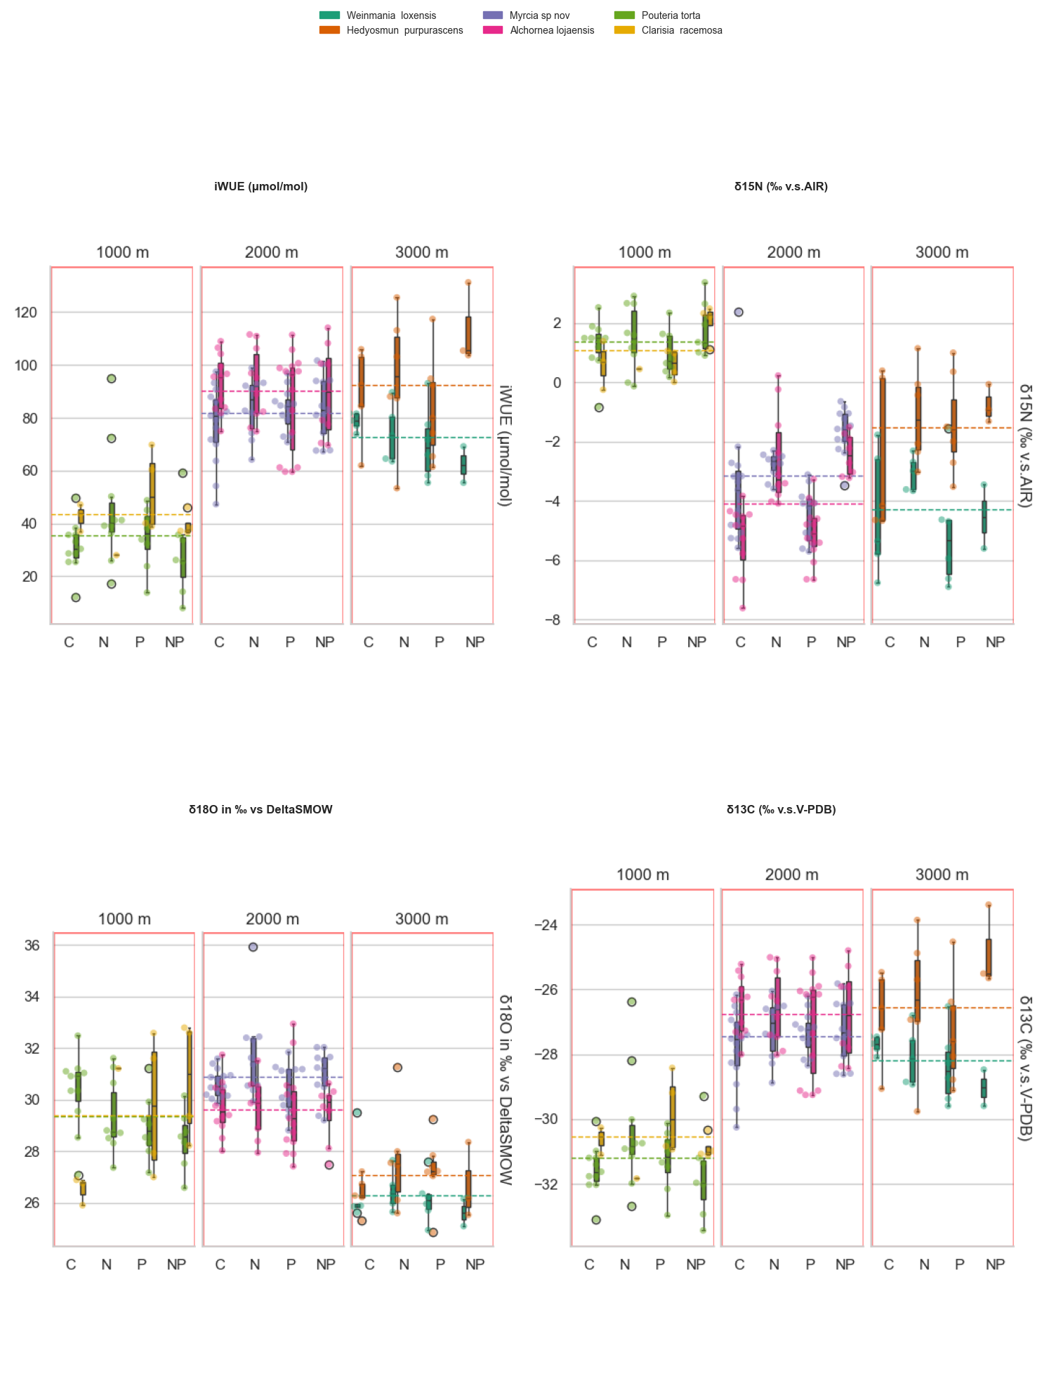

Fig 1. Preliminary results: W-use efficiency (WUE) and stable isotope compositions of nitrogen (δ¹⁵N), oxygen (δ¹⁸O), and carbon (δ¹³C) were measured in the NUMEX experimental setup across three elevations. Patterns indicate that San Francisco (2000 m) and Cajanuma (3000 m) exhibit more similar physiological responses compared to Bombuscaro (1000 m), except when examining δ¹⁸O values, where a distinct pattern emerges.
Overall, no significant treatment effects were detected on intrinsic water-use efficiency (iWUE). (lmer(`iWUE (μmol/mol)` ~ name + N + P + N*P + (1|name) + (1|Plot) per elevation group).
However, species-specific responses were observed (tested with two way ANOVA with N*P interaction):
- Pouteria torta showed a significant difference in δ¹⁸O among treatments. Pouteria on the control group has higher δ¹⁸O than in the nutrient added plots.
- Myrcia sp. exhibited a significant variation in δ¹⁸O and δ¹⁵N.
- Clarisia sp. responded significantly in δ¹⁵N.
- Alchornea lojaensis. responded significantly in δ¹⁵N.
These findings suggest that while overall treatment effects are limited, individual species display distinct isotopic responses, reflecting potential differences in physiological adjustments to nutrient addition along the elevation gradient.

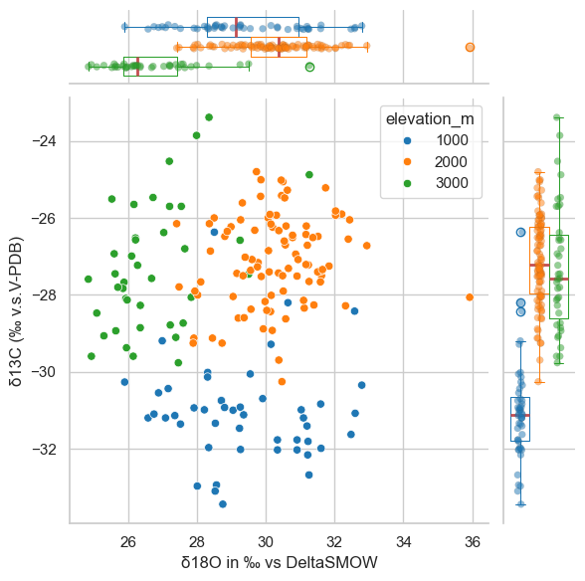
Fig 2. Stable isotope δ¹³C plotted against δ¹⁸O of leaf cellulose (δ¹⁸O_{cel}). Each color corresponds to an elevation group, in blue Bombuscaro n= 48, green Cajanuma n= 39, and orange San Francisco n = 95.

